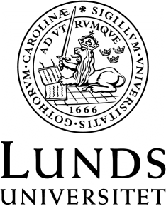
Språk- och litteraturcentrum
Filmvetenskap
Required reading for
FIVA05: Scandinavian and European Film Culture (1-30 ECTS) Autumn 2020, Course 2
or
FIVA07: Scandinavian and European Film: Festivals, Criticism, Society (7,5 ECTS), Autumn 2020
(Fastställd i Sektionsstyrelse 2, SOL-Centrum, 2 juni 2020)
A Companion to Nordic Cinema (2016). Hjort, Mette and Lindqvist, Ursula (eds.), Malden: Wiley-Blackwell. (Selection, ca 250 pp.)
Film criticism in the digital age (2015). Frey, Mattias and Sayad, Cecilia (eds.), New Brunswick, New Jersey: Rutgers University Press. (Selection, ca 100 pp.)
Film festivals: history, theory, method, practice (2016). Valck, Marijke de, Kredell, Brendan and Loist, Skadi (eds.), Routledge, London. (238 pp.)
European cinema and television: cultural policy and everyday life (2015). Bondebjerg, Ib, Redvall, Eva Novrup and Higson, Andrew (eds.), Houndmills, Basingstoke, Hampshire: Palgrave Macmillan. (265 pp.)
The Europeanness of European Cinema: Identity, Meaning, Globalization (2015). Harrod, Mary, Liz, Mariana and Timoshkina, Alissa (eds.), London: I. B. Tauris. (Selection, ca 150 pp.)
Additional readings available online or via the course platform. (Ca 100 pp.)

